Created by: David Rubio G.
Blog: https://soceame.wordpress.com/
GitHub: https://github.com/DRubioG
Last modification date: 11/03/25

To implement differential ports in Libero, you have to use the components provided by Libero to implement them.
To do this, Libero provides the following components:
- INBUF_DIFF: this buffer transforms the differential input signal into a simple signal.
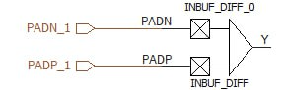
- OUTBUF_DIFF: this buffer transforms the simple output signal into a differential signal.
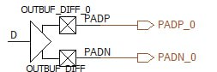
- TRIBUF_DIFF: this buffer enables the differential output.
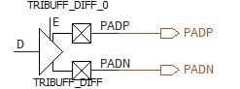
- BIBUF_DIFF: this buffer allows you to work with bidirectional differential input/output signals.
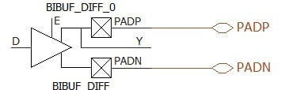
Finally, it should be noted that there is also a buffer for differential clocks called CLKBUF_DIFF, this buffer allows you to transform the differential input clock signal into a simple clock signal.
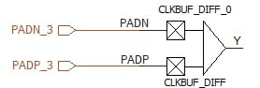
NOTE: the differential pins have to be the same differential pairs used in the chip. It only allows us to assign positive pins, the negative ones are auto-assigned.
If you check the pins, when marking pin A19 as positive, it auto-assigns the negative to A18.
